Software Engineering Group Project

AUM Group

User Interface Specification Use Case Document

|  |  |
| --- | --- |
| Author: | [nah37] |
| Config Ref: | SE_JC_UI_01 |
| Date: | 2018-03-06 |
| Version: | V1.2 |
| Status: | Draft |

Department of Computer Science

Aberystwyth University (Mauritius Branch Campus)

Flic-en-Flac

Mauritius

SY23 3DB

Copyright © Aberystwyth University 2018

CONTENTS

CONTENTS 2

1. Introduction 3
   1. Scope 3
   2. Objectives 3
2. Typical Users 3
3. use cases 3
   1. Use case 1 – Playing a new game 4
   2. Use case 2 – Playing a saved game 4
   3. Use Case 3 – Help 4
   4. Use Case 4 – Settings 4
   5. Use Case 5 – Score board 4
4. Errors 4
   1. Error 1 – Player name not entered 4
   2. Error 2 – Player name contains special characters 4
   3. Error 3 – Filename not entered 5
   4. Error 4 – Filename contains special characters 5
   5. Error 5 - Filename already exists 5

REFERENCES 5

DOCUMENT HISTORY 6

# Introduction

# 1.1 Purpose of this Document

The purpose of this document is to describe the user interface design of the JoggleCube Game made by the AUM group.

## Scope

The User Interface Specification covers the typical users expected to play the JoggleCube Game. It describes each possible use cases that might occur, any errors that might occur and how thy will be dealt with.

## Objectives

This document is meant to help the development of the JoggleCube Game by providing a clear description of the user interface. It states how the user can interact with the system and how will the system respond.

# Typical Users

The typical user of the JoggleCube game is a second year Computer Science student. The student has the role of the player.

# use cases

The diagram below gives an overview of the different scenarios that are possible while using the JoggleCube Game.

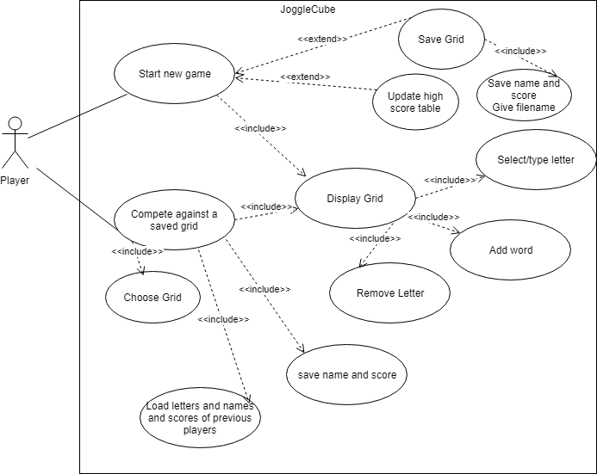

## Use case 1 – Playing a new game

The start menu is displayed once the game starts and the player has to click on “New Game” option to start a new playing grid. The player can alter the view of the game grid in the “settings” option.

Once the game starts, the user can identify a clickable 3*3*3 game gird populated with randomly generated letters, a word entry text box and a timer which start ticking from 3 minutes. The player can click on a letter on the game grid to start forming a word, and from that point can only select letters adjacent horizontally, vertically, or diagonally from the most recent letter they have selected. The player can unselect a letter by clicking a second time on the selected letter or simply by pressing backspace. The possible move is display in white and once selected it turns yellow.

Once the player has completed a word he/she clicks on the “ADD WORD” to finalize the word and the latter will be check against a library of possible words. In case the user is unsatisfied with the word he/she can click on “CLEAR WORD” to completed remove the selected word instead of having to unselect everything. If is word is correct, then it is added to the list of correct word on the screen. If the word is not legal then a error message will pop up on the game screen.

The game continues until the countdown reaches 0 and a game over screen is displayed together with the game score. The game screen has several functions allowing the user to choose whatever he/she wants to do either save the game for other challenger, plays a new game, load a saved game or simply exits to the start menu.

## Use case 2 – Playing a saved game

In order to play a saved game, the player can either click onto the “Load Game” in the start screen or on the game over screen. A menu of game grids is displayed together with their respective high score is available for the player to choose which one to challenge. Once decided, the player then click on “load game” to start the game. The gameplay is similar with new game and if the player is able to challenge the high score the score for this level is overwrite with the new score and challenger name.

## Use Case 3 – Help

The user can click on the “help” button at the bottom right of the start menu. This will open up a new window with instruction on how to play the game, how the scoring feature is and information about the game.

## Use Case 4 – Settings

The “settings” button on the start screen will lead the user to a new window allowing the player to alter the view of the game grind of the game or adjust the game sound of the game.

## Use Case 5 – Score board

The user can have access to the overall high score of the game in the “scoreboard” button located at the start menu screen. Only the top 10 scores and names will be displayed on it.

# Errors

## Error 1 – Player name not entered

The player is asked to enter his name either when he has finished playing a new game and his score is among the ten best score ever or when he is playing a saved game. The save button is enabled only if the name textbox contain at least a character.

## Error 2 – Player name contains special characters

The player is asked to enter his name either when he has finished playing a new game and his score is among the ten best score ever or when he is playing a saved game. If the player name contains any special characters, an error message “Special characters not allowed” is displayed to the player and the game is not saved. The player is prompted again to enter his name. The game is saved only when the player name does not contain any special characters.

## Error 3 – Filename not entered

The player can save the grid he has just played with if that was a new game. Then, the player is prompted to enter a filename in which to save the grid. If player clicks the save button and the textbox for the filename is empty, then the game is not saved. The save button is enabled only if the filename textbox contain at least a character.

## Error 4 – Filename contains special characters

The player can save the grid he has just played with if that was a new game. Then, the player is prompted to enter a filename in which to save the grid. The game is not saved if the filename contains any special characters and an error message “Special character not allowed” is displayed to the user. The player is prompted again to enter the filename.

## Error 5 - Filename already exists

The player can save the grid he has just played with if that was a new game. Then, the player is prompted to enter a filename in which to save the grid. If the filename name entered by the user already exists then, the game is not saved and an error message “filename already exists”. The player is prompted again to enter a filename until he has entered one that does not exist.

REFERENCES

[1] Software Engineering Group Projects: User Interface Specifications Standards. C. J. Price. SE.QA.04. 1.0 Release

DOCUMENT HISTORY

| *Version* | *CCF No.* | *Date* | *Changes made to document* | *Changed by* |
| --- | --- | --- | --- | --- |
| 1.0 | N/A | 2018-03-07 | N/A -draft version | Nah37 |
| 1.1 | N/A | 2018-03-07 | Added the use case diagram and errors | Nah37 |
| 1.2 | N/A | 2018-03-08 | Updated the use-case and minor changes | Jty |